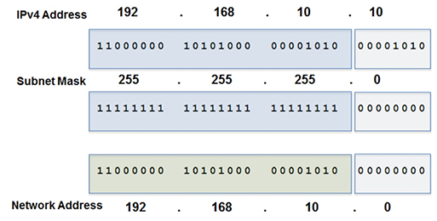

1 AND 1 = 1

arp –a

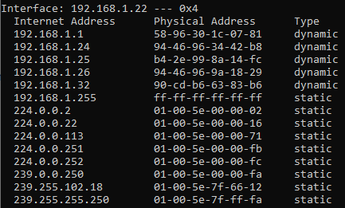

ipconfig /all

netstat -r